**Terraform Assignment**

**Run Jenkins**

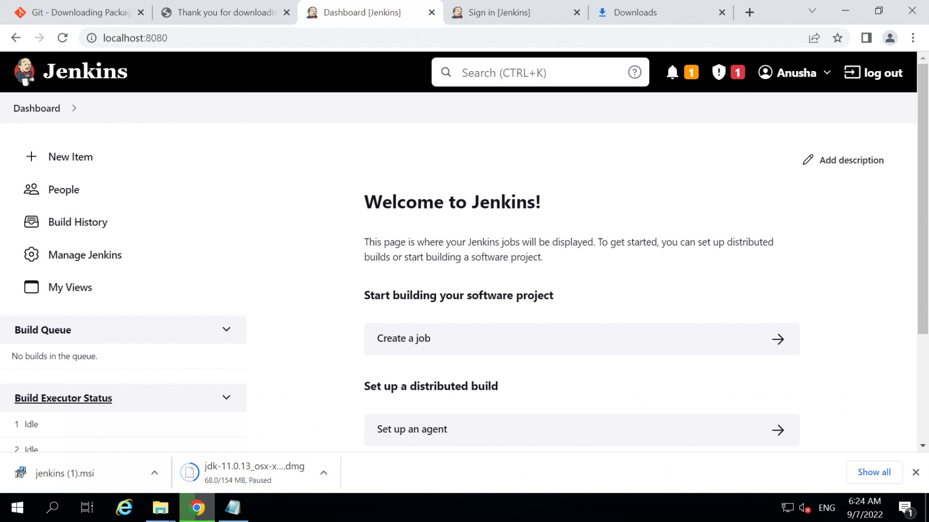

**Launch 3 ec2 with keypair via terraform**

